Data and Light
Student Edition
Name: | Subject(s)/Course(s): Geometry |  | Date:
Synopsis and Narrative:
CDs, DVDs, and Blue Rays™ store large amounts of binary data (patterns of 0s and 1s) in a series of tiny grooves and pits, arranged in a spiral from the center of the disk to the outside edge. The distance between each spiral is called the groove spacing or track pitch. The smaller the groove pitch the more binary data that can fit on a disc. Since the grooves are periodic, the grooves on the disc will diffract light into multiple beams, acting as a diffraction grating. The track pitch for a CD or DVD can be determined by analyzing the diffraction pattern created when shining a laser on the disc.
Challenging Question or Problem:
What is the separation or track pitch for a CD and DVD? Theoretically, what is the smallest separation or track pitch for a Blu-Ray ™ disc?
Phenomenon and Manufacturing Application:
Data centers, storing data
Examples (in action):  CD’s, DVD’s, and Blu-Ray ™ |  |  |  | Vocabulary:  Diffraction
State and National Standards & 21st Century Skills:
Next Generation Math Learning Standards:
GEO-G.CO.1 - Know precise definitions of angle, circle, perpendicular line, parallel line, and line segment, based on the undefined notions of point, line, distance along a line, and distance around a circular arc as these exist within a plane.

GEO-G.CO.12 - Make, justify and apply formal geometric constructions.

GEO-G.SRT.6 - Understand that by similarity, side ratios in right triangles are properties of the angles in the triangle, leading to definitions of sine, cosine and tangent ratios for acute angles.

GEO-G.SRT.8 - Use sine, cosine and tangent ratios and the Pythagorean Theorem to solve right triangles in applied problems.

G-SRT.D.11+ - Understand and apply the Law of Sines and the Law of Cosines to find unknown measurements in right and non-right triangles (e.g., surveying problems, resultant forces).

A1-N-Q.3 - Choose a level of accuracy appropriate to limitations on measurement and context when reporting quantities.

Practices:
4. Model with Mathematics
5. Use appropriate tools strategically
6. Attend to precision
Materials and Equipment:
Lasers, Red, Green, Blue
White stand
CD
DVD

Not included in kit
Protractor
Calculator
Pencil
Safety:
Lasers are light sources that can permanently damage the eye. They are not toys. When you are not using the laser, TURN IT OFF. Do not let the laser beam wander around the room. Always keep the laser beam below the chest area of all people in the room. Never look into the laser beam or at laser light reflected off of a shiny surface. If you stare into a laser beam for a period of time, permanent and irreparable damage to the eye can occur. The Laser Blox set provided in the kit is a Class IIIR laser product.
Learning Targets:
- Students will make, justify, and apply geometric constructions to create an expression that determines the separation or track pitch on a disc.
- Use trigonometric ratios and the Pythagorean Theorem to solve right triangles in applied problems.
- Understand and apply the Law of Sines and the Law of Cosines to determine an angle.

Discussion Questions:
- What are the differences between a CD and a DVD?
________________________________________________________________________________________________________________________________________________________________________________________________________________________________________________________________________________________________________________________________________________________________________

- Hold up a CD and a DVD to the light. What are the visible differences between the two?
________________________________________________________________________________________________________________________________________________________________________________________________________________________________________________________________________________________________________________________________________________________________________

CD and DVD Players
by Chris Woodford
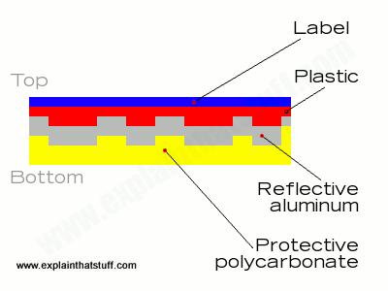
CDs, DVDs, and Blu-RayTM Discs are made from an original "master" disc. The master is "burned" with a laser beam that etches bumps (called pits) into its surface. A bump represents the number zero, so every time the laser burns a bump into the disc, a zero is stored there. The lack of a bump (which is a flat, unburned area on the disc, called a land) represents the number one. Thus, the laser can store all the information sampled from the original track of music by burning some areas (to represent zeros) and leaving other areas unburned (to represent ones). Although you can't see it, the Compact Disc (CD) holds this information in a tight, continuous spiral of about 3-5 billion pits. If you could unwrap the spiral and lay it in a straight line, it would stretch for about 6 km (roughly 3.5 miles)! Each pit occupies an area about two millionths of a millionth of a square meter. That's pretty tiny!

Once the master disc has been made, it is used to stamp out millions of plastic duplicates that you buy and put into your player or computer. Once each disc is pressed, it's coated with a thin aluminum layer (so it will reflect laser light), covered with protective polycarbonate and lacquer, and the label is printed on top.

So what's going on in your disc player when the disc spins around?

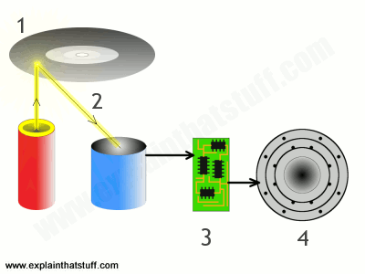
Inside your disc player, there is a miniature laser beam (called a semiconductor diode laser) and a small photoelectric cell (an electronic light detector). When you press play, an electric motor (not shown in the above diagram) makes the disc rotate at high speed (up to 500rpm). The laser beam switches on and scans along a track, with the photocell, from the center of the disc to the outside. The motor slows the disc down gradually as the laser/photocell scans from the center to the outside of the disc (as the track number increases, in other words). Otherwise, as the distance from the center increased, the actual surface of the disk would be moving faster and faster past the laser and photocell, so there would be more and more information to be read in the same amount of time.

The laser (red cylinder) flashes up onto the shiny (under) side of the CD, bouncing off the pattern of pits (bumps) and lands (flat areas) on the disc. The lands reflect the laser light straight back, while the pits scatter the light.

Every time the light reflects back, the photocell (blue cylinder) detects it, realizes it's seen a land, and sends a burst of electric current to an electronic circuit (green) that generates the number one. When the light fails to reflect back, the photocell realizes there is no land there and doesn't register anything, so the electronic circuit generates the number zero. Thus the scanning laser and electronic circuit gradually recreates the pattern of zeros and ones (binary digits) that were originally stored on the disc in the factory. Another electronic circuit in the CD player (called a digital to analog converter or DAC) decodes these binary numbers and converts them back into a changing pattern of electric currents.
Artwork showing how a CD player uses a laser beam to read bumps from a compact disc and turn them back into audible sounds.

A loudspeaker transforms the electric currents into sounds you can hear (by changing their electrical energy into sound energy).

Procedure:
- Place the CD in the center of the white stand and place the CD on the desk with the label side facing away from the table. The CD should be at a height where the laser reflects off of the center of the disc.

- Using the red laser, place the laser directly on the table and reflect the laser off of the polycarbonate (plastic) side of the disc. DO NOT LOOK DIRECTLY INTO THE LASER BEAM! Turn off the laser when not in use.

- Align the laser so that it is perpendicular to the surface of the CD. When the laser is perfectly perpendicular to the CD, the laser beam will reflect off of the CD directly back onto the laser.

- Place the protractor perpendicular to the disc and align the protractor so that the laser passes directly over 90° and the origin or vertex. The origin or vertex of the protractor must align directly over the vertex of the laser beam where it reflects off of the surface of the CD.

- Determine the angle between the laser beam passing through 90° and n=1.
θ =_____________

- CD’s, DVD’s, and Blu-RayTM discs contain thousands of tracks, which are very small slits, or rulings. When light hits the surface of the disc the light will spread out and change direction as it passes through the small openings and reflects off of the back surface. Light with multiple colors or wavelengths are broken up into their component colors or wavelengths, which is why a CD or DVD shows a rainbow in white light. The laser that you are using today contains light of only one color or wavelength. The wavelength of the laser is written on the laser. Record the wavelength below.
λ Wavelength for red laser =_____________

Deriving the Equation and Finding the Distance Between Track Pitch:
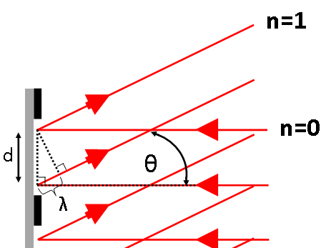
- The laser dot seen at n=1 is the result of constructive interference. Constructive interference from the grating occurs when the path difference, λ from two rays that are interacting with each other is a whole wavelength. This wavelength λ can be found on the label of the laser used. Using the diagram below, come up with an expression that allows you to find distance between the tracks or rulings d, based on the angle θ and the wavelength of light, λ. Show all work in the box below.

Calculating the Distance Between Track Pitch:
- The variable d is the distance between track pitch on the disc. The total number of tracks that can fit on the disc determine the amount of data that the disc can hold. The smaller the track pitch distance, the greater number of tracks that can fit on a disc. For the CD, using the angle θ and the wavelength of light, λ found earlier, determine the distance in mm between the track pitch or ruling in millimeters and then convert that to inches. (there are 25.4 millimeters in an inch)

- For the DVD, repeat the steps in the procedure.
θ =_____________
λ Wavelength for red laser =_____________

- Using the angle θ found for the DVD and the wavelength of light, λ, determine the distance in mm of the track pitch or ruling in millimeters and then convert that to inches. (there are 25.4 millimeters in an inch)

Blu-RayTM Discs
Blu-RayTM discs get their name from using a blue laser to read the information on the disc. The blue lasers have a wavelength of 405 nm. What is the theoretical minimum track pitch that can be accomplished, with zero error using a blue laser? Show all work below and explain your reasoning.

________________________________________________________________________________________________________________________________________________________________________________________________________________________________________________________________________________________________________________________________________________________________________
________________________________________________________________________________________________________________________________________________________________________________________________________________________________________________________________________________________________________________________________________________________________________
________________________________________________________________________________________________________________________________________________________________________________________________________________________________________________________________________________________________________________________________________________________________________

